This has core 10 feature that need proper customization

1. Please remove this screen and use the video clip I sent you

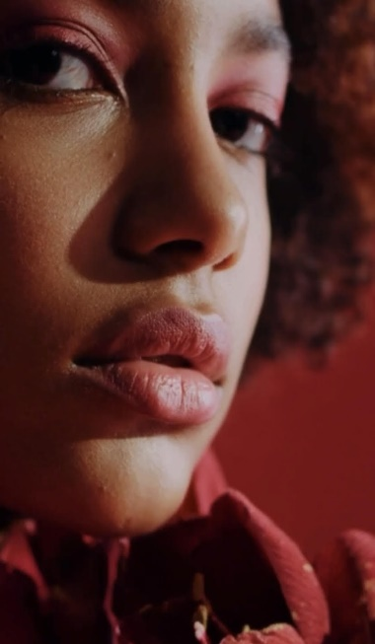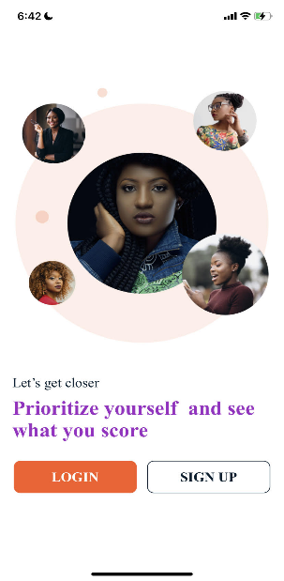

🡺

1. Camera/video. To upload video and take photos it should be a custom camera NOT default camera. (See prototype) (and the camera need to have face recognition new addition)

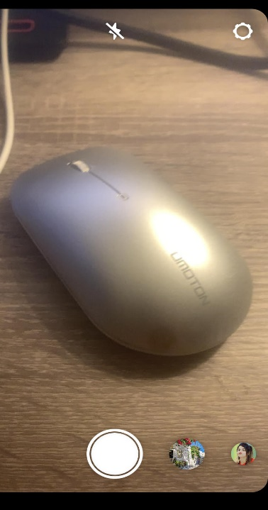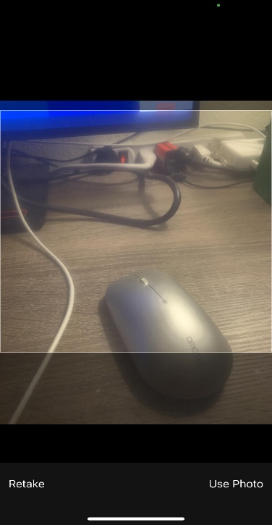



1. Ranking. Ranking for men and women has different description

Men part has men comparison 1-10 and women part has women comparing from 1-10 and separate description all this list of is manageable from the admin panel. I admin can make changings to the list (see prototype)

1. Signups: Signup with Instagram is missing from the IOS and the US phone code is +1 NOT +91
2. Photo select: user should be able to select multiple photos at a time NOT one each.

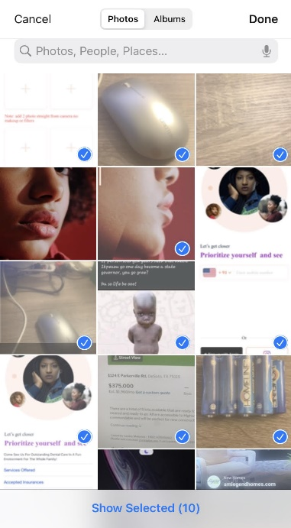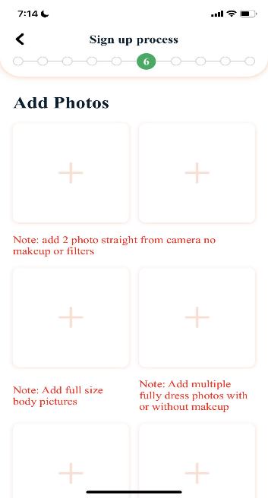



1. Please ensure this is working properly because it would test, now there is no way to know if it work or not because there is not data to test with

